Assignment 07

# Title:

# Dashboard 1: Maximum Magnitude

## Visual 1: Packed Bubbles plot

Find top three years with maximum magnitude. What are those years?

Ans: The top three maximum magnitude years are 1960,1964 and 2004

## Visual 2: Box and Whisker Plot

### Median:

### Maximum:

### Minimum:

## Dashboad1 :

# **Dashboard 2: Map View**

### **Map View:**

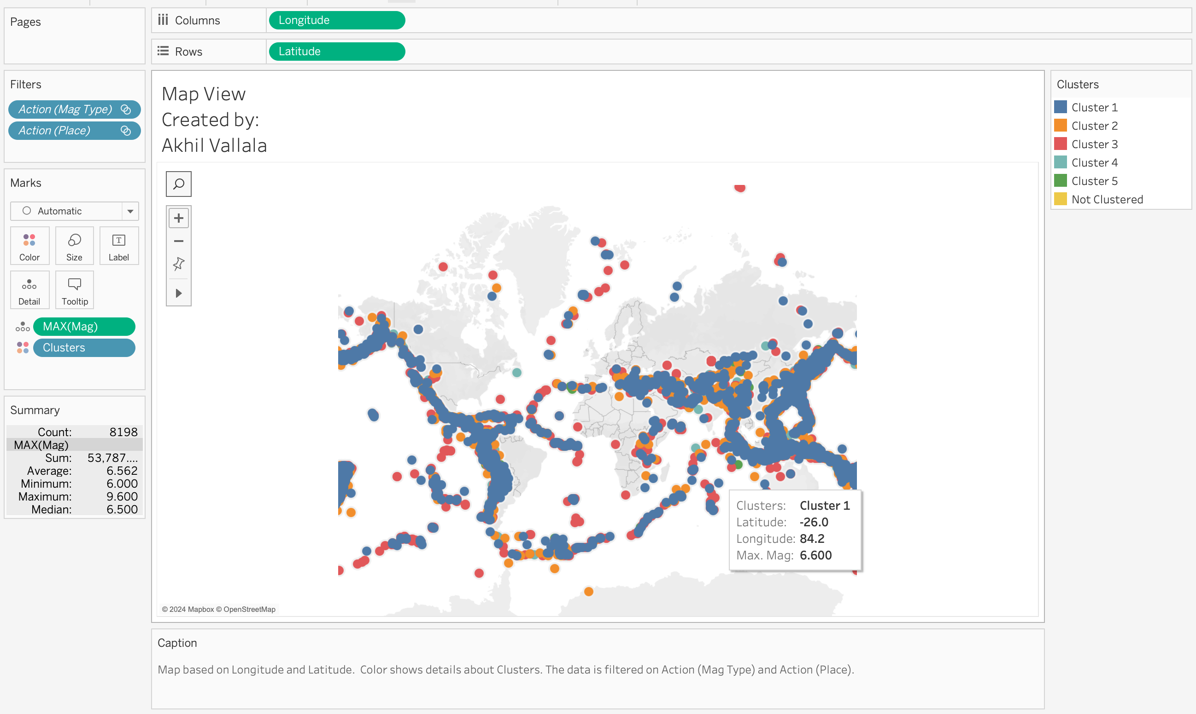

Perform **‘cluster analytics’ using K-Means clustering on Max Magnitude**

Check cluster description. Which cluster has all the max magnitude earthquakes ?

Cluster 5 has the highest average maximum magnitude of earthquakes at 8.169, indicating that this cluster contains the earthquakes with the greatest magnitudes.

### Gannt view:

## **Dashboard 2: Map View**

# **Visualizations of choice**

### Visual1: Max Mag of Each Mag Type

### Visual2: Max Depth of Each Mag Type

# Dashboard3: Seismic Intensity and Depth Profiles by Magnitude Type

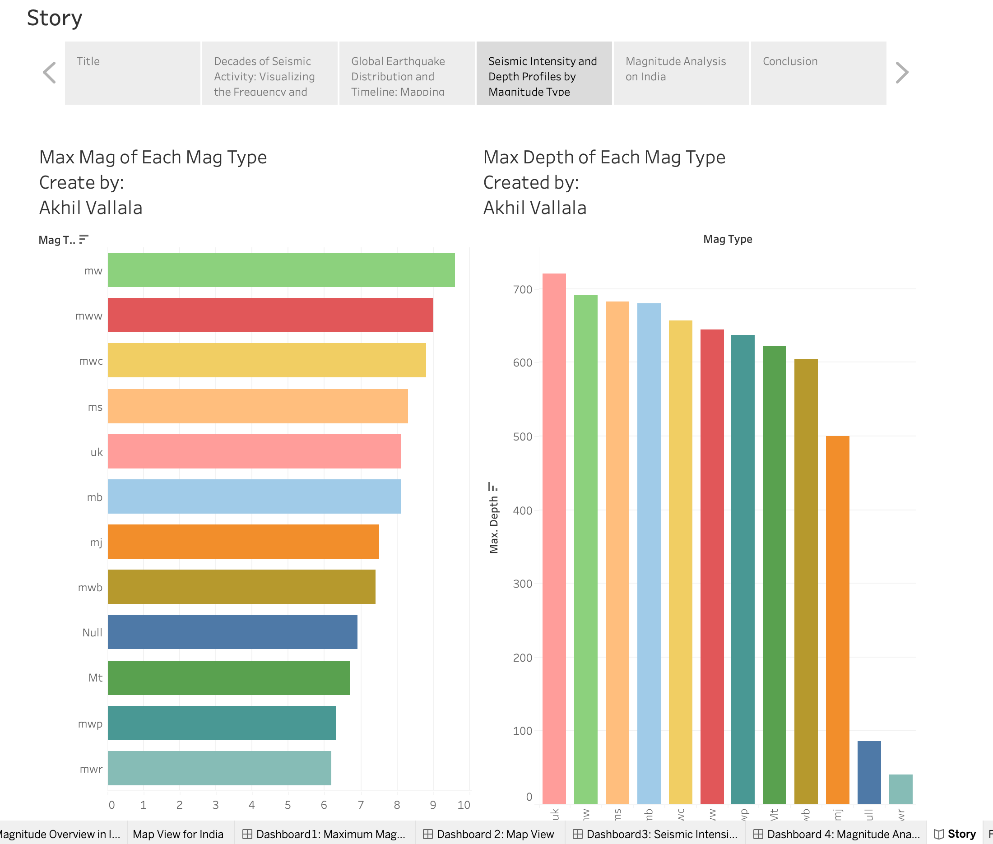

## Visual 3: Seismic Magnitude Overview of India and the Indian Ocean

Dashboard 4: Magnitude Analysis on India

# Conclusion:

# Task2: Predict the magnitude intensity of earthquakes for the next 20 years. Present the actual and predicted values in one visualization.

# Task3: Publish your visualization on Public Tableau and submit the Tableau link and the screenshot document.

Public Link:

<https://public.tableau.com/app/profile/akhi.vallala/viz/assignment07bigdata/Forecasting>